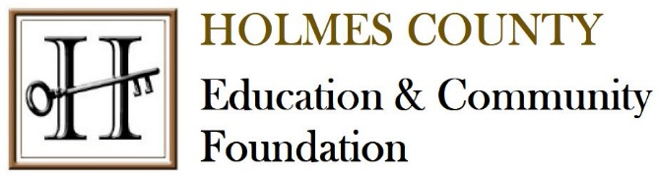
2025 Community Grants
Holmes County Education & Community Foundation’s Community Grants provide funding for programs and projects that improve the quality of life of individuals within Holmes County.

Grant Awards
Applicants may request a minimum of $2,500 and up to $15,000. The amount of the award each year will vary based on the available funds. Proposals that demonstrate the most effective use of funds in the context of their programming have the greatest chance for success.

Eligibility
All applicants must possess nonprofit status or nonprofit/charitable intent.

Duration of Grants
Grants are valid for a period of up to one year, with the expectation that the full amount of the grant will be used within that time.

Geographic Range of Grants
Grants must benefit Holmes County, Ohio residents.

Leadership and Fiscal Accountability
Grantee organizations must have the leadership capacity, financial stability, and appropriate procedures in place for fiscal and organizational accountability.

Evaluation
A community grant selection committee consisting of HCECF board members and staff will review the grant proposals. To make the best use of available funds, the selection committee will look for one or more of the following when reviewing proposal requests:
- The project is well planned.
- The use of funds will help to carry out the purpose of the project/program.
- Support from HCECF is vital or important to the success of the project/program.

Grant awards may not be used to carry on propaganda or otherwise attempt to influence legislation, participate in or intervene in political campaigns on behalf of or in opposition to any candidate for public office, or to conduct, directly or indirectly, any other registration drive (within the meaning of Section 4945(d)(2) of the Internal Revenue Code).

HCECF makes grants only to organizations that are recognized by the Internal Revenue Code as nonprofit, tax-exempt organizations, charitable organizations, education institutions, or qualified governmental agencies. The Foundation does not make grants to individuals.

Note: If you are seeking a grant for a group or agency that is not listed above (i.e. booster club, youth group, parent/teacher organization), your group must be affiliated with one of these types of primary organizations to be eligible to apply. When completing the online application, the organization contact information and EIN/Tax ID Number applies to the primary organization. Awarded grants will be given to the primary organization for the benefit of your affiliated group.

Final Report
Organizations receiving grants are required to submit a final report to HCECF within one year of receipt of the grant which will include a request for documentation of the use of grant funds.

Application Process and Deadlines
All grant applications must be downloaded through our online link, completed, and returned back to us via email or dropped off at our office by October 1st. Projects will be selected by November 30th and awards will be sent out by December 31st.

